A000-Afr-Egy-Ushabti-Red Faience, Gold applique, Black pigment-30th Dyn-**381-343 BCE**

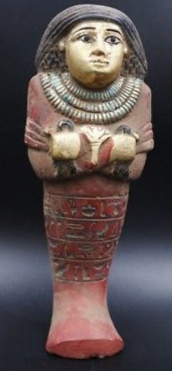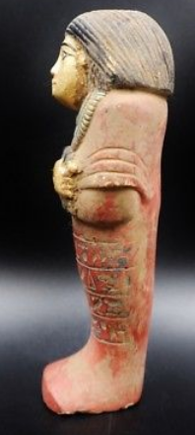

**Case no.: 2**

**Accession Number:**

**Formal Label:** Ushabti-Red Faience, Gold applique, 30th Dyn-**381-343 BCE**

**Display Description:**

**Fine Authentic Ancient Egyptian Terracotta Ushabti**

**LC Classification: NB 75**

**Date or Time Horizon:** 30th Dyn-**381-343 BCE**

**Geographical Area:** Deir El Bahri, Thebes

**Map:**

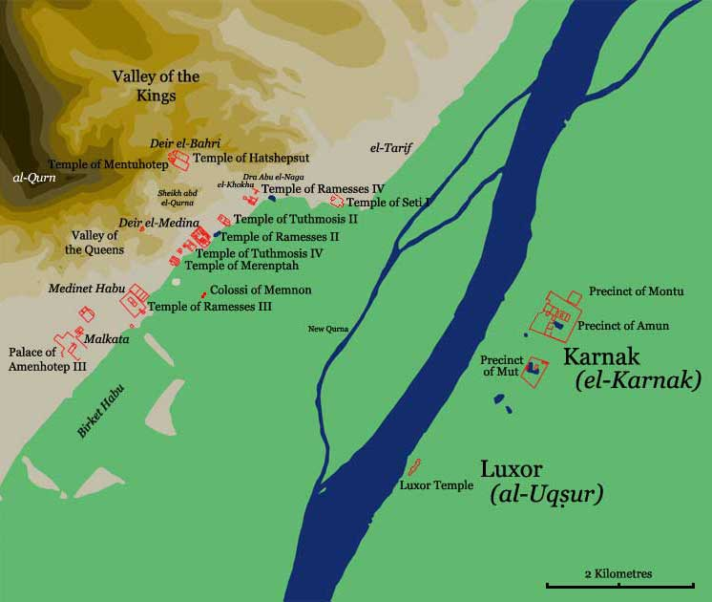

Location of Deir el Bahri after http://www.odysseyadventures.ca/articles/thebes/thebes_map.jpg

**GPS coordinates: Latitude:** 25° 44' 10.79" N, **Longitude:** 32° 36' 16.79" E

**Cultural Affiliation:** 30th Dyn-**381-343 BCE**

**Media:** Red Faience, Gold applique, Black pigment

**Dimensions:** 6.721 in, 170.72 mm

**Weight: 15 7/8 oz, 452 gm**

**Condition: original**

**Provenance:** Deir el Bahri

**Discussion:**

**References:**